January 4th, 1901
San Francisco Examiner

World Speaks to World with Mysterious Signals through Vast Space – Tesla, The Electrician, Says He Received a Message from Mars.

Nikola Tesla has had the first call of the century from a neighboring planet. He has communicated with Mars, he delares (sic), while on Pike’s Peak, delving into the mysteries of the wireless transmission of electrical energy.
The summons was faint, but, according to Tesla, not to be mistaken.
A new voice from a planet, millions of miles removed, was spoken over one of the myriad of unwired telephones of the universe, and there, near the lonely mountain peak, in the fathomless calm of night, the voice at last found a listener and world spoke to world in language strange at first, but sure to be clearer, says Tesla, ere the Twentieth Century has finished its course.
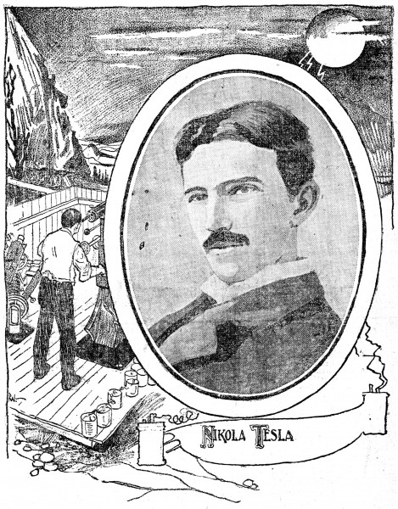
While investigating electrical phenomena on Pike's Peak, Nikola Tesla, the famous inventor, says he plainly distinguished disturbances which must have been produced on one of the planets in the solar system.
He Distinguished Feeble Electrical Disturbances Which Could Not Have Been of Solar or Earthly Origin.
New York, January 3. — It was in investigating feeble electrical actions transmitted through the earth that I made some observations which are to me the most gratifying.
Chief among these were certain feeble electrical disturbances which I could barely note at times, and which by their character unmistakably showed that they were neither of solar origin nor produced by any causes known to me on the globe. What could they be?
I have incessantly thought of this for months, until finally I arrived at the conclusion, amounting almost to knowledge, that they must be of planetary origin. I have perfected my transmitting apparatus so far that I can construct a machine which will without the slightest doubt be fully competent to convey sufficient energy to the planet Mars to operate one of these delicate appliances which we are now using here, as, for instance, a very sensitive telegraph or telephone instrument.
Now, since we ourselves are already so far advanced, is it unreasonable to believe that of twenty or twenty-five planets of the solar system, one, if not more, might be ahead of us in the evolution? Where there is sun’s heat and moisture, life must originate and go on developing, just as a stone must fall to earth.
The Discoverer Believes One of the Planets May Have Already Perfected a Scheme of Interplanetary Communication.
New York, January 3. — Tesla’s almost incredible discovery was made by him in Colorado two years ago while he was conducting experiments in relation to wireless transmission of energy. He worked in a laboratory specially constructed. When be was asked to-day to give some visible form or notation to the message he had received, be smiled emphatically
and said:
“As I have already said, one of the planets in the solar system may be ahead of us in the evolution. Their means of interplanetary communication may be perfect, but we have yet to learn their sign language. It is impossible at present, even to suggest a code and my observations to the Red Cross Society on New Year’s Eve were purely speculative, but for purposes of illustration they will answer the purpose at present.
“It is enough to say at this time that a message from Mars which might be a triangle to them would appear as some other form to us, and vice-versa. These differences can only be reconciled by time and careful study. It is wonderful enough, is it not, that a beginning has been made.
“On Pike’s Peak I set out to carry on my experiments along three different lines:
“First, to ascertain the best conditions for transmitting power without wires; second, to develop apparatus for the transmission of messages across the Atlantic and Pacific oceans, and, third, to work on another problem, which involves a still greater mastery of electrical force.”
“I consider of still greater importance than even the transmission of power without wires, and which I shall make known in due course.
“In my laboratory in New York I was able to go only to electrical discharges of sixteen feet in length, and I had only reached effective electrical pressures of about 8,000,000 volts. To carry the problems further I had to master electrical pressures of at least 50,000,000 volts, and electrical discharges were necessary for some purposes measuring at least fifty or one hundred feet.
“The results I attained were far beyond any I had expected to reach. I found that my mental vision was incomparably clearer, so much so that I could look back in thought to my laboratory in New York, and in examining familiar objects in the rooms there I could notice the smallest scratch on them, and in scanning the features of my assistants I could notice the slightest marks on their faces, as though they had been actually before me. Now in the city the mental images are much duller.
“One of the first observations I made in Colorado was of great scientific importance and confirmatory of a result I had already obtained in New York. I refer to my discovery of the stationary electrical waves in the earth. The significance of this phenomenon has not yet been grasped by technical men, but it virtually amounts to a positive proof that, with proper apparatus, such as I have perfected, a wireless transmission of signals to any point on the globe is practicable. When I read statements to the effect that such a thing is impossible and recall the numerous adverse criticisms of my expressed confidence that I can ultimately accomplish this, I experience a feeling of satisfaction.
“As I think over it now it seems to me that only a man absolutely stricken with blindness, insensible to the greatness of nature, can hold that this planet is the only one inhabited by intelligent beings.”
Washington (D. C.), January 3. — Professor S. I. Brown of the United States Naval Observatory, in discussing Nikola Tesla’s announcement, says:
“Any proclamation coming from Tesla is likely to be received with considerable incredulity. I have been locking in vain for some practicable results to follow the extravagant claims that he has constantly made during the past half-dozen years. Most of his discoveries have materialized only in statements such as this which he gives out every once in a while for publication.
“His assertion that he has found that some planet is signaling to the earth is remote even to the point of impossibility. He contradicts himself so frequently in the interview that it is hard to tell what he really means. He says, for instance, that his instruments have been affected by an unknown power, of which he is in ignorance. Then he goes on to declare his belief that it is due to an effort on the part of one of the planets to signal to us.
“He indicates that Mars might be the world which is attempting to communicate with us. It is most peculiar that any discovery involving Mars should be made just now. Once in every fifteen years that planet reaches its greatest distance from the earth, when it is 62,000,000 miles away. The nearest that it ever gets is 36,000,000 miles. It happens that just now Mars is at the farthest distance that it ever gets from us. Certainly it is hard to understand why, at such an inopportune time, signals from the Martians should have been detected by Tesla.
“Tesla indicates that this method of communication is based upon wireless telegraphy. Up to the present time the greatest distance that a message has ever been sent by wireless telegraphy is about 100 miles. Yet he gravely talks about signaling through interplanetary space for a distance of 62,000,000 miles. The power of the electric wave vibrations involved in wireless telegraphy is inversely as the square of the distance they have traversed. Thus the electrical power required on the planet Mars in order to communicate with this world would be 3,600,000,000,000,000 times as great as the power received here. Even the faintest sign of energy that might be received here when multiplied by that would represent an incredible force on the surface of the planet Mars. We can hardly use such an enormous power as that.
“Mars may be populated. “We cannot make any positive assertions regarding that, but it will take more than a mere statement from Nikola Tesla to prove the existence of signals from the planet to us.”
Professor A. S. Skinner of the United States Naval Observatory says: “This is the first I have heard of Tesla’s latest accomplishment. You can rest assured it is imaginative and visionary. I do not care to make any further comment on it or the possibilities of the case.”
Father John B. Hagan, professor of astronomy at the Georgetown University, has this to say: “Astronomers do not look forward to the discovery of communication between the planets, and, in fact, take no interest in and pay no attention to experiments of this character. There is no internal contradiction to the problem, being only a question of means on our side and the possibility of inhabitants in Mars. The first we have not discovered and the second we do not know anything about. Whether the atmosphere on the two planets would be an obstacle to communication would depend upon discoveries yet to be made. I would have to see a purely technical account of the experiment before I could form an idea of the value of the claim that communication has been established between the earth and Mars. In an account devoid of scientific minutae it is impossible to dissect it with any degree of accuracy. I would prefer not to make any comments on this particular alleged discovery of Tesla’s.”
Professor T. J. J. See of the Naval Observatory says: “I have read the story about this discovery. I do not care to say anything about it.”

